**Front-End Task: Converting Design to Code**

Basically, you would need to convert a design into a working webpage. In this task, there are 4 underlying tasks that you will be evaluated upon.

To get started:   
1. You can start with a starter kit provided in the attached zip folder. In the kit, there are 7 images used in the design. (logo, banner, and 5 carousel sliders’ images)

2. Alternatively, you can fork the starter kit at my github repository where you can clone and develop from there using nodejs, npm and gulp (the instruction to setup is provided in the readme). The css development for this setup uses scss plugin.

3. For the optional task 4, the data file can be found in the data folder where there is an xml file and a json file. You can choose either file format to complete the task. Do not hardcode the values into the html as that defeats the purpose of the task objective. To call the data using ajax, you may need to setup a server to overcome CORS limitation. To help you a little, I would suggest to use python’s http.server setup (<https://docs.python.org/3/library/http.server.html>) or if you are using the code from the repository, you can just gulp and the browsersync component will setup the server environment for you.

Please submit the files – both working (src, if any) and final (dest) versions – via a zip folder or through a repository link (github or bitbucket, if any. And provide a setup instruction).

1. Main Navigation

The designs provided consist of a desktop version and a mobile version. Be sure to take note the different appearance of both versions and adjust accordingly. You may decide the breakpoint for the mobile version as you see fit. You should use Bootstrap to help you.

Desktop –

Mobile – hidden and expanded form

1. Parallax Scrolling

This task tests your css understanding for object positioning and how you structure your html file. Create the parallax scrolling section as shown in the example below. It should work on both Desktop and Mobile version. (Double click on the video file below to see the works)

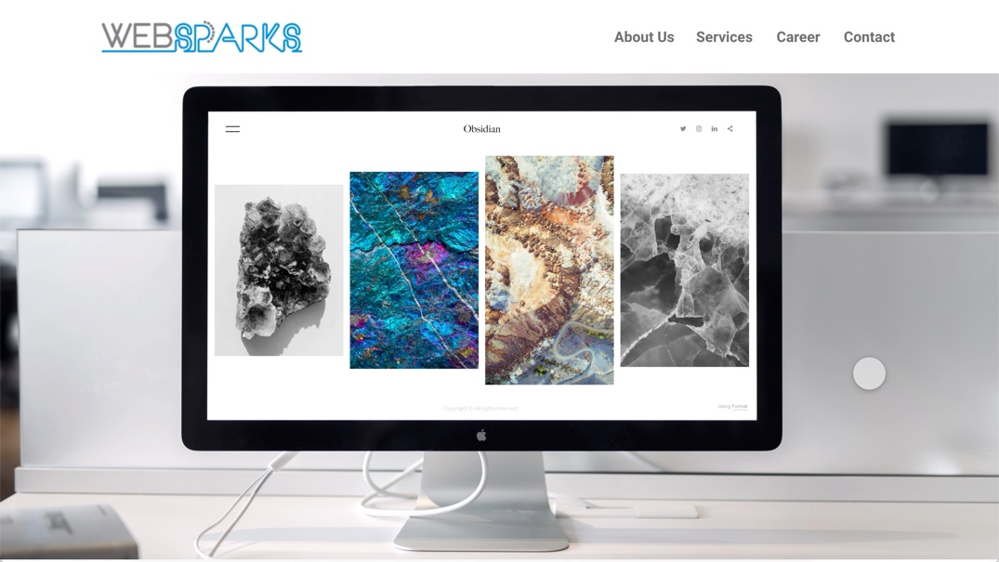

1. Carousel Slider

This task works on your ability to use external libraries. You would need to create a carousel using slick.js (<https://kenwheeler.github.io/slick/>). In addition to the external library usage, you may need to modify your object positioning a little to create the overlay on each picture using css. Download and use the library to create this section. It should also work on both desktop and mobile.

The complete carousel is in this order – Eggs, Leaves, Prawns, Lettuce, Tomatoes

1. News Listing

This is an optional part that tests your ability to retrieve data and displaying them accordingly. Use jQuery’s ajax call to retrieve the data from either the xml or json format and create the display as below. Note that this task relies heavily on your understanding of jQuery for DOM manipulation as well.

Hint:

